

Structural Design

(Inside View)

**Vertical corrugation**

Design#:

**200594-01**

Customer:

**DeMet's Candy**

Description:

**TTLS 9x2.9OZ Small Heart Box Kroger DRC**

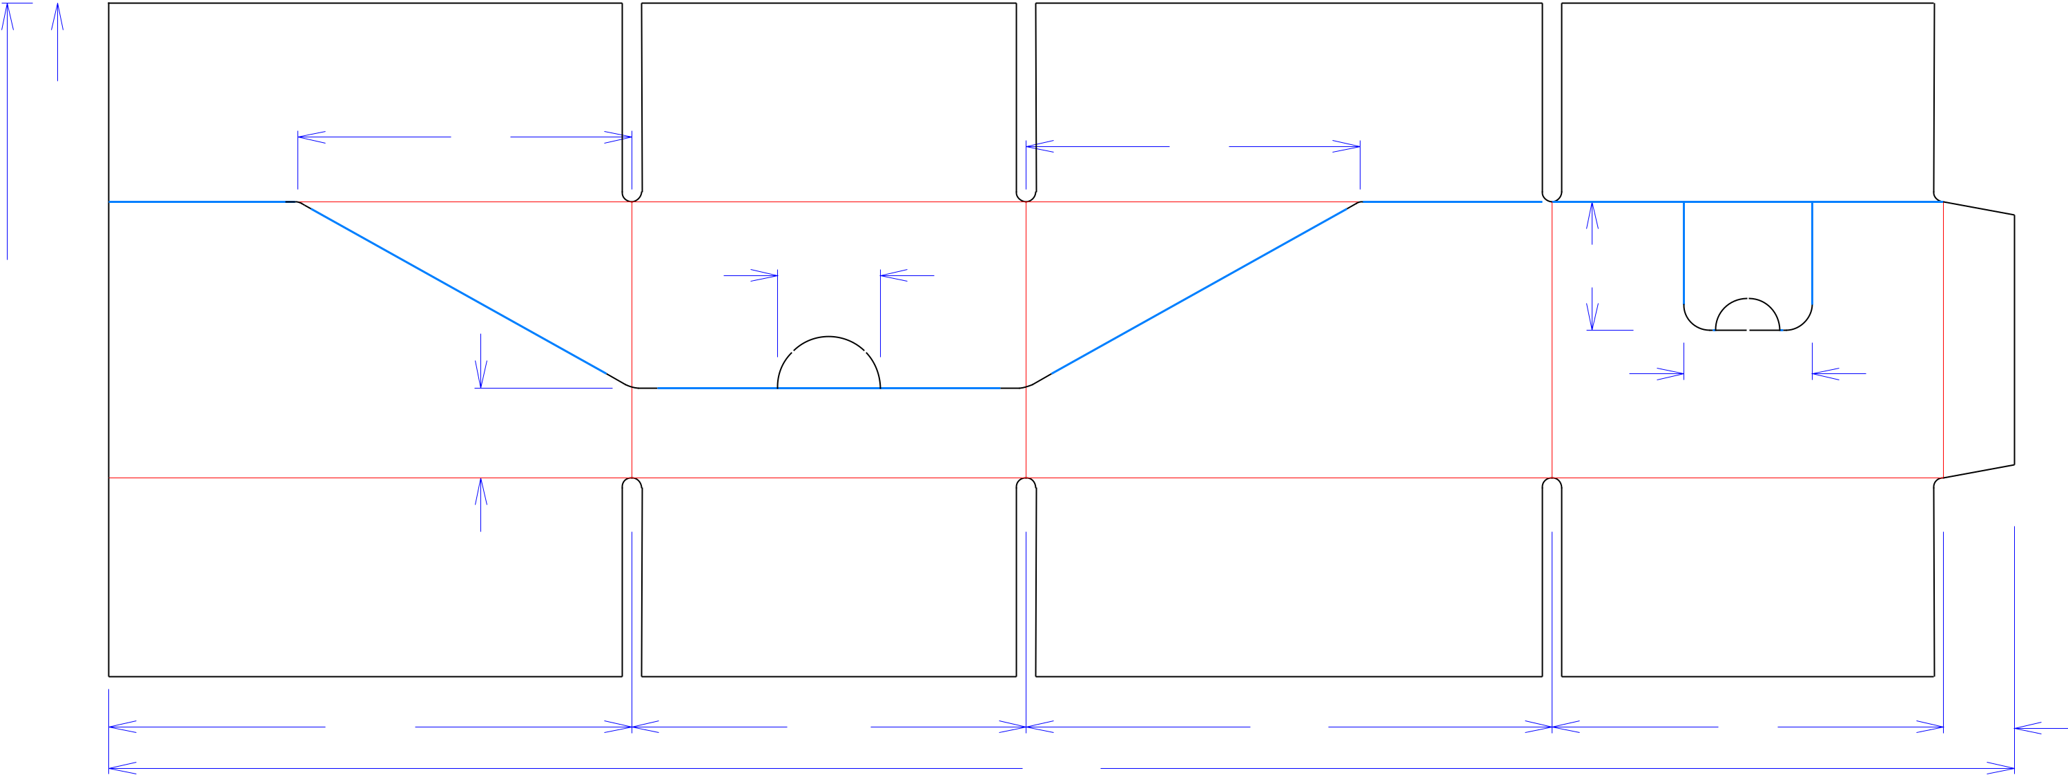

|  |  |  |  |  |  |  |  |
| --- | --- | --- | --- | --- | --- | --- | --- |
| 37*/*8 |  |  |  |  | **SINGLE-OUT DRAWING** | |  |
| 61*/*2 | 61*/*2 |  |  |  |  |  |
|  |  | Qty/Unit: | |  |  |
|  |  |  |  | Style: | **JDC** |  |  |
| 131*/*8 | 2 | 2 | 2 | Board: | **32BW** |  |  |
|  |  | 1*/* | |  |  |  |
| 53*/*8 |  |  |  | Combination: **36MW - 23M - 35HP** | | |  |
|  |  | 21*/*2 |  |  |  |  |
|  |  |  | I.D. : | **10+1/8 x 7+9/16 x 5+1/8** | |  |
|  |  |  |  |  |
|  | 13*/*4 |  |  |  |  |  |  |
|  |  |  |  | Area of Blank - Waste : | | **3.24 sq. ft.** |  |
| 37*/*8 |  |  |  | Waste on Blank : | | **4.32%** |  |
|  |  |  | Finished Piece Weight: | | **0.34 lbs./152.90g** |  |
|  |  |  |  |  |
|  |  |  |  | Over-all Blank: **13+1/8 x 37+1/8** | | |  |
| 103*/*16 | 711*/*16 | 101*/*4 | 75*/*8 | 13*/*8 |  |  |  |



|  |  |  |
| --- | --- | --- |
| 371*/*8 | **X= Crush Areas Required** |  |
|  |  |

Notes:

**from 110013-01**

Revision Info: **[0] 07/22/2020**

Designer: **Amy Kirchhoff**



Cut Crease Crease with Matrix Cut Crease Half Knife Cut Tear Tape Perforation



Designright and Copyright of DS Smith Corrugated Packaging Ltd. This technical Specification is subject to Manufacturing tolerances. Drawing dimensions shown are crease to crease. Date printed: 07/22/2020